NHS Special Measure Request Form

Employee Name
Trust
Station Name
Approval Given By
Approver Name and Email Address

Measurer Name
Email Address
Contact Number
Signature

Please state below if this is a standard stock size requiring an alteration i.e. longer sleeve, wider collar OR new size garment

Required Product | Tick if required | Quantity required | Special Measure Requirement
SS Operational Trousers – Navy | ☐
Operational Trousers | ☐
Operational Shirt – Green | ☐
EOC Operational Shirt - Green | ☐
SS Operational Shirt – Navy | ☐
Polo Shirt | ☐
EOC Polo Shirt | ☐
SS Polo Shirt | ☐
T-Shirt – WHITE | ☐

Please Note Trust Name below:

Please note the reason for Special Measure

Please answer the following questions. Circle the correct answer where appropriate
Are you providing images of yourself to help with sizing | YES NO
Do you have any fabric allergies i.e. Cotton, Wool, Polyester etc | YES NO
If YES please state allergen

Do you require a Special measure smaller or shorter than the standard size? | SMALLER SHORTER
What is the standard stock size closest to your required measurements?

Please note any additional comments

Measuring Specifications
TOPS

Name: | Height (ft)
Gender: | Height (cm)
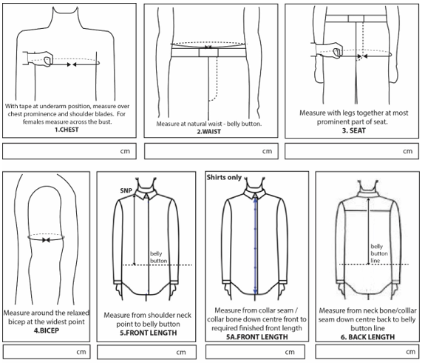

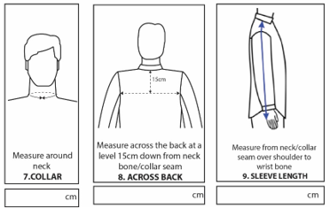

BOTTOMS
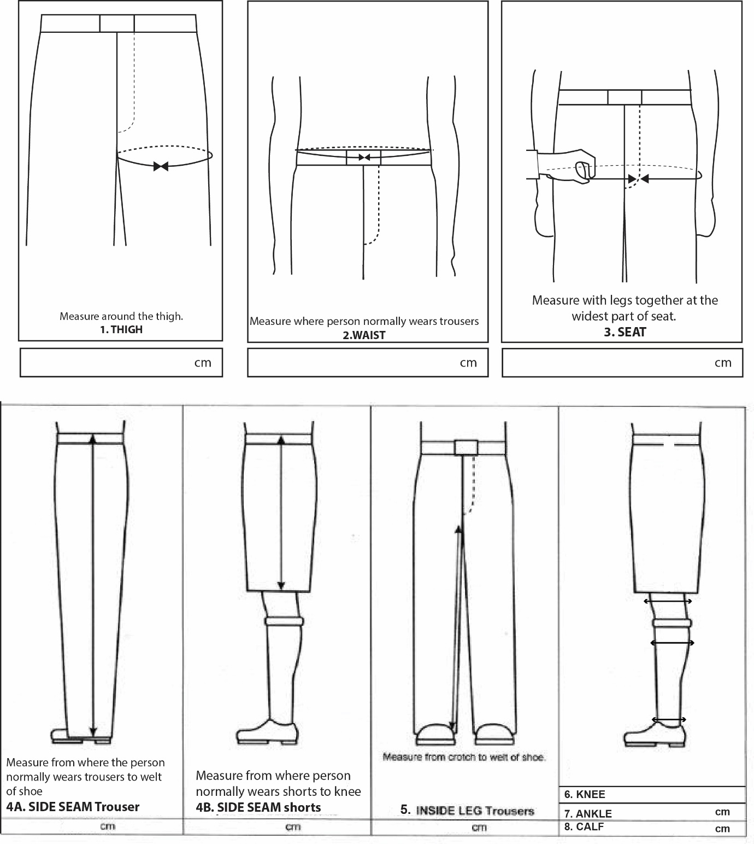

Current uniform trouser measurements
- Outside leg (along seam)

- Inside leg (along seam)

- Closed waistband (half measurement)

- Hips
Where does the person normally wears their trousers

