

**URGENT MEDICAL DEVICE RECALL/URGENT FIELD SAFETY NOTICE**

**Customer Response Form**

**Specimen Collection Device: Cepheid Catalog Number P/N 900-0370**

Please review the Urgent Medical Device Correction Notice and complete this Online Acknowledgement Form **within 10 business days upon receipt of this notification**.

Complete this form **even** if affected product is no longer in your inventory

**Account Information**

**\*** Facility Name

**\*** Cepheid Account Number (if unknown please submit N/A)

**\*** Facility Address

**\*** Facility City

**\*** Facility State/Province

**\*** Facility Zip/Postal Code

**Form Completed By:**

**\*** Your First Name

**\*** Your Last Name

**\*** Telephone Number

**\*** Email Address

**\*** Title

**Acknowledgement**

**Please acknowledge receipt of this letter and then choose between options A and B.**

**\*** I acknowledge receipt of this letter

Option A: I am not requesting any replacement product

Option B: I am requesting replacement product

**Product Information**

**Product Disposal Attestation: I attest that I will dispose of any remaining Specimen Collection Device: Cepheid Catalog Number P/N 900-0370 from batch 230397900, 230535300, 230627500, and/or 231887900**

Quantity Collection Device On-hand (if none enter “0”):

**Signature**

**\*** Full Name (Signature)

**\*** Date (MM/DD/YY)

***It is important that your organization takes the actions detailed in this letter and confirms receipt of notification for regulatory tracking purposes.***

**Cepheid has partnered with IQVIA MedTech to assist in this correction notice. For any assistance regarding online response processing or product return for this notice, please contact IQVIA MedTech using the information below:**

**E-Mail:** [**cepheidrecall-24far007@iqvia.com**](mailto:cepheidrecall-24far007@iqvia.com)

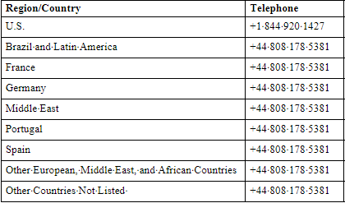

* - required